
Department of CSE

B.Tech. CSE Trimester -5

Roll Number-2520030154
Name- Pothuru Bhavana Manaswini

Cloud Infrastructure and Services
25CS2206E

Experiment - 1
SKILL 1:
Create an IAM user with programmatic access only, generate and download the Access Key ID and Secret Access Key, and configure an AWS billing alert to receive an email notification when the Free Tier usage approaches or exceeds the specified limit.
IAM User Creation, Access Key Generation and AWS Billing Alert Configuration.

Prerequisites
- Active AWS account.
- Access to the AWS Management Console using the root user or an account with administrative permissions.
- Valid email ID for receiving billing notifications.

Part A: Create an IAM User
Step 1 – Open the AWS Management Console and sign in.
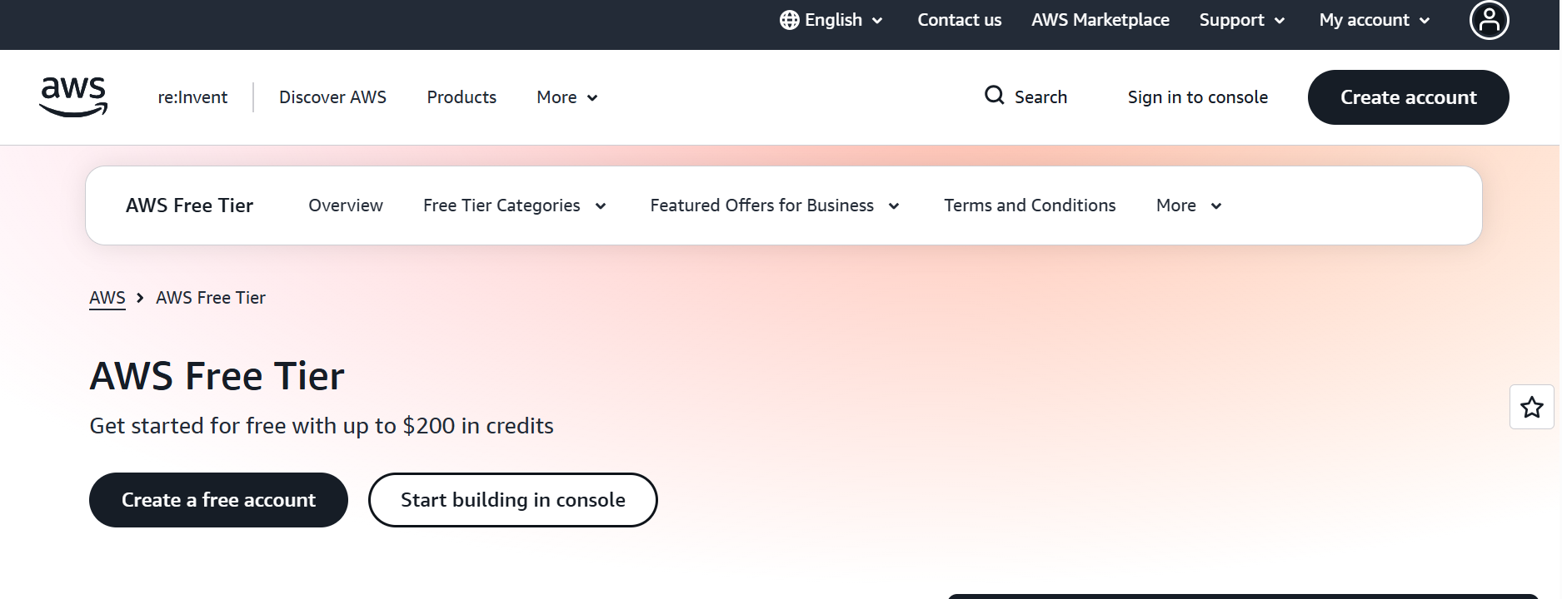
Figure: Step 1
Step 2 – Search for IAM and open the IAM service.
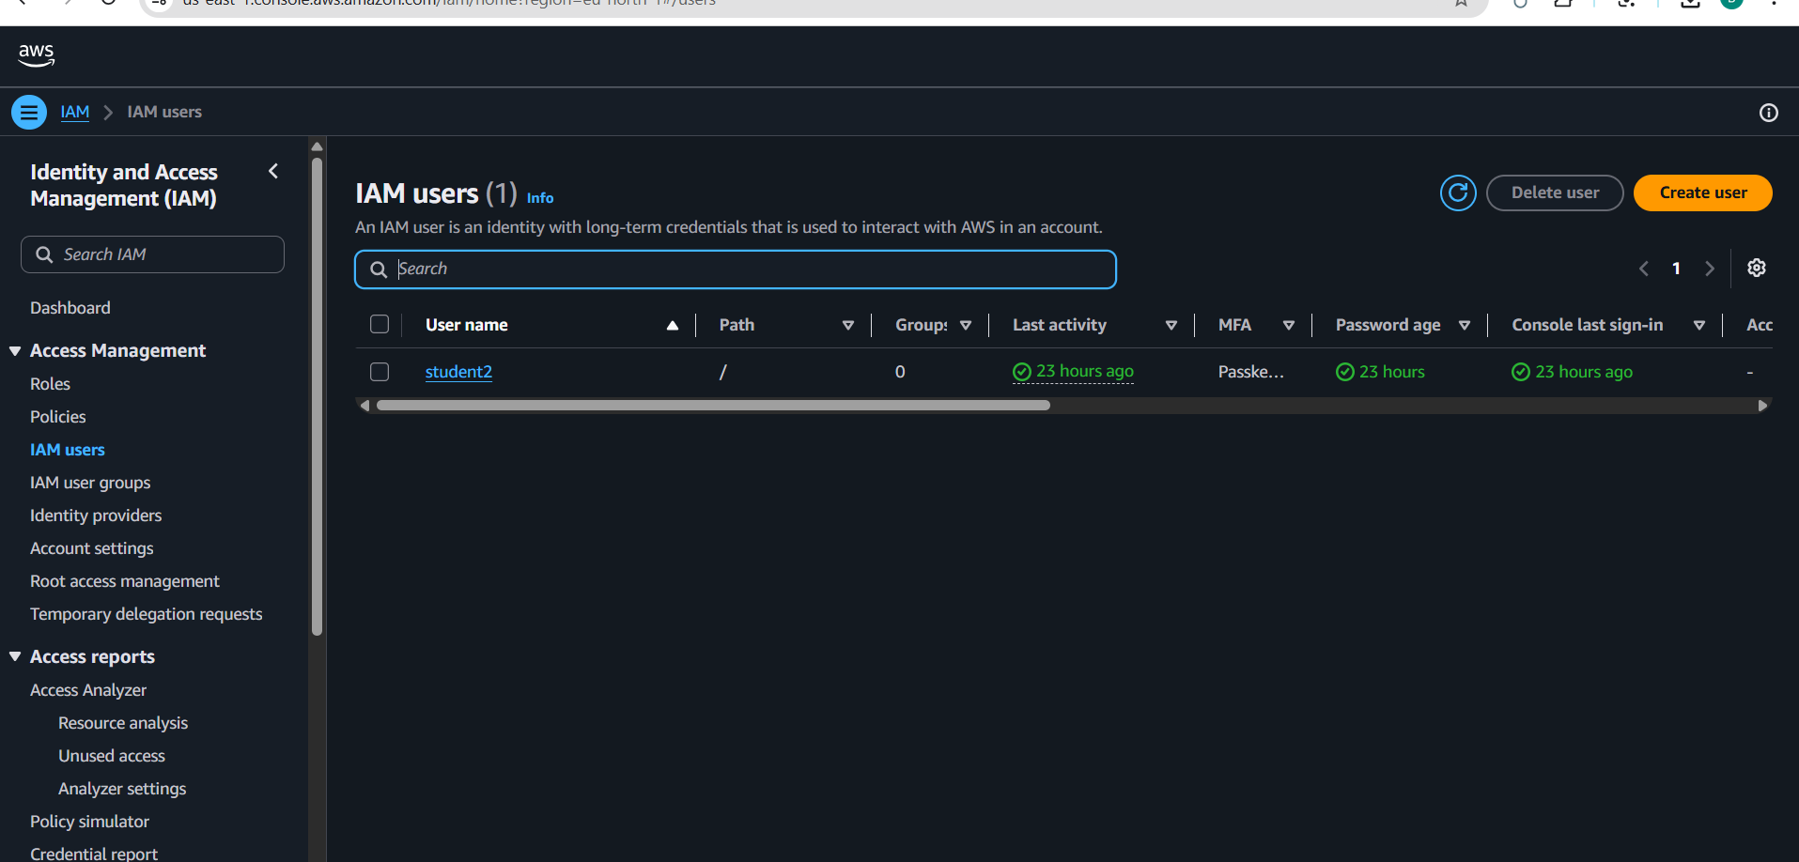

Step 3 – Select Users and click Create user.

Step 4 – Enter a username and keep console access disabled.
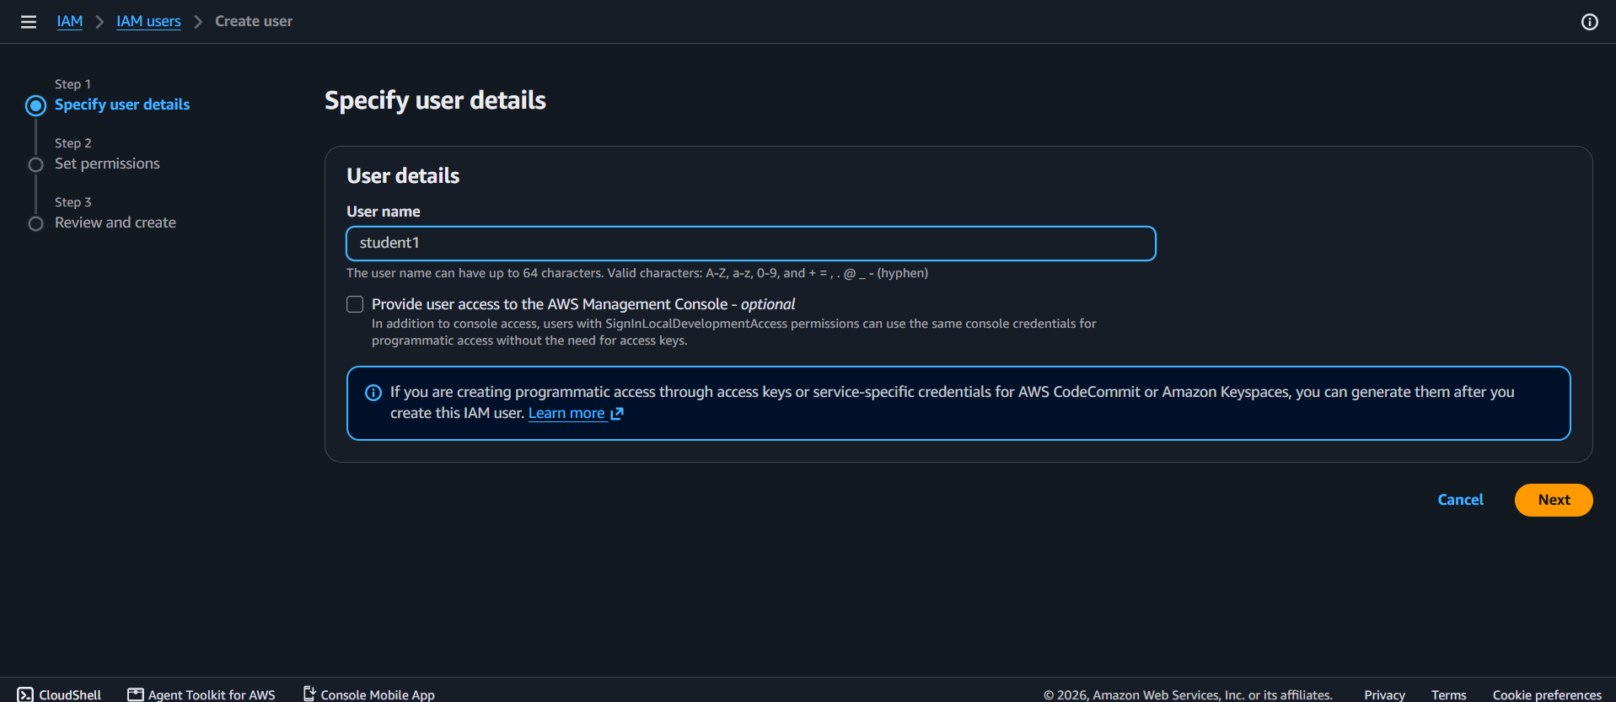

Step 5 – Select Attach policies directly and choose the required permission policy.
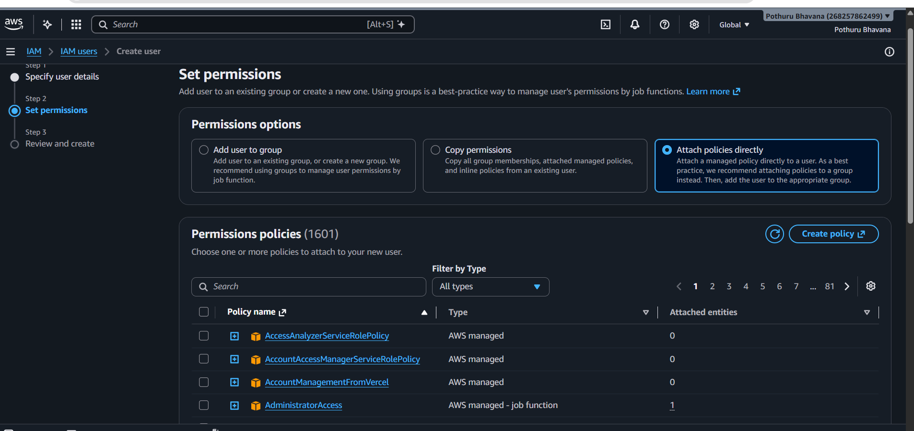
Figure: Step 5
Step 6 – Review the details and click Create user.
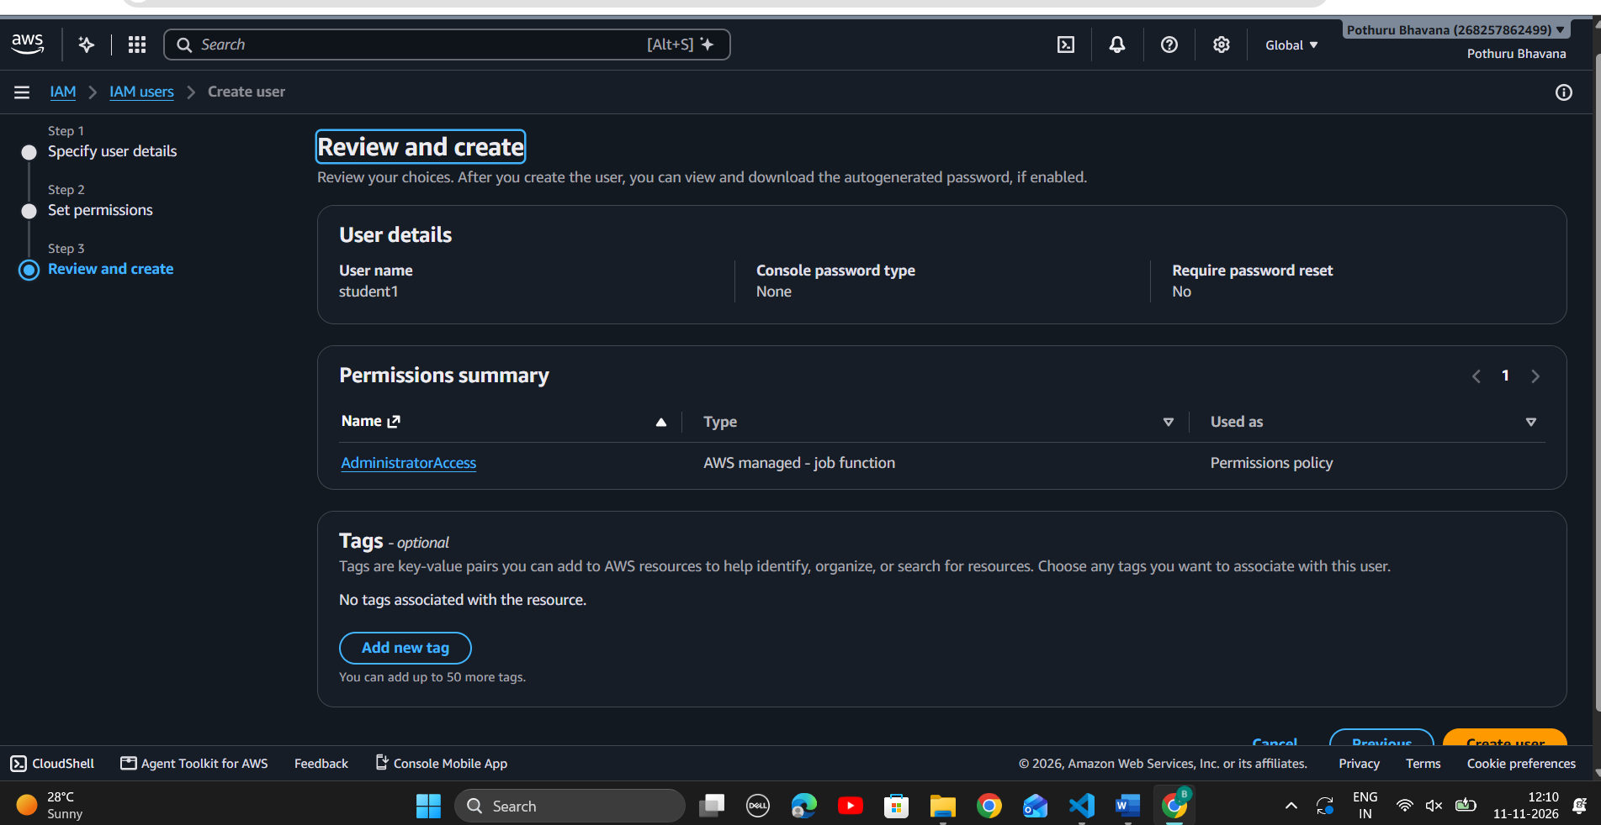
Figure: Step 6
Step 7 – Check the Users list to confirm that the user was created.
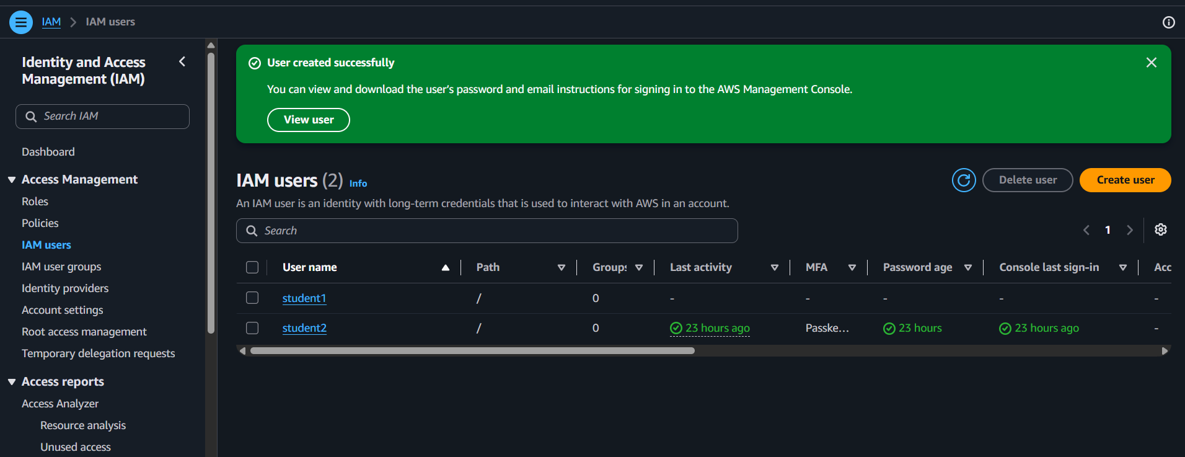

Part B: Generate and Download Access Keys
Step 1 – Open the created IAM user and select Security credentials.
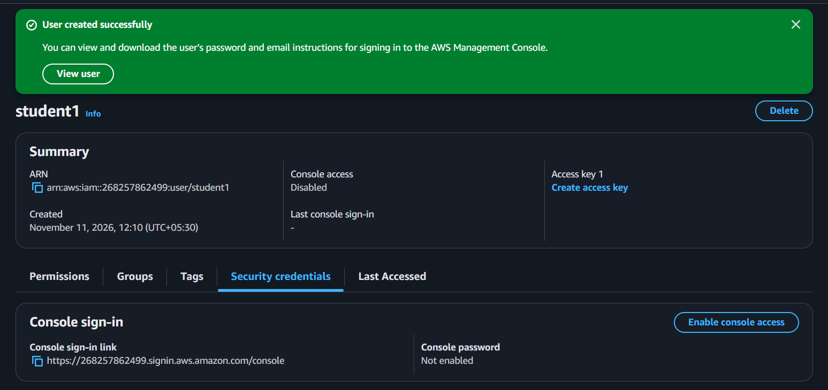

Step 2 – Scroll to Access keys and click Create access key.
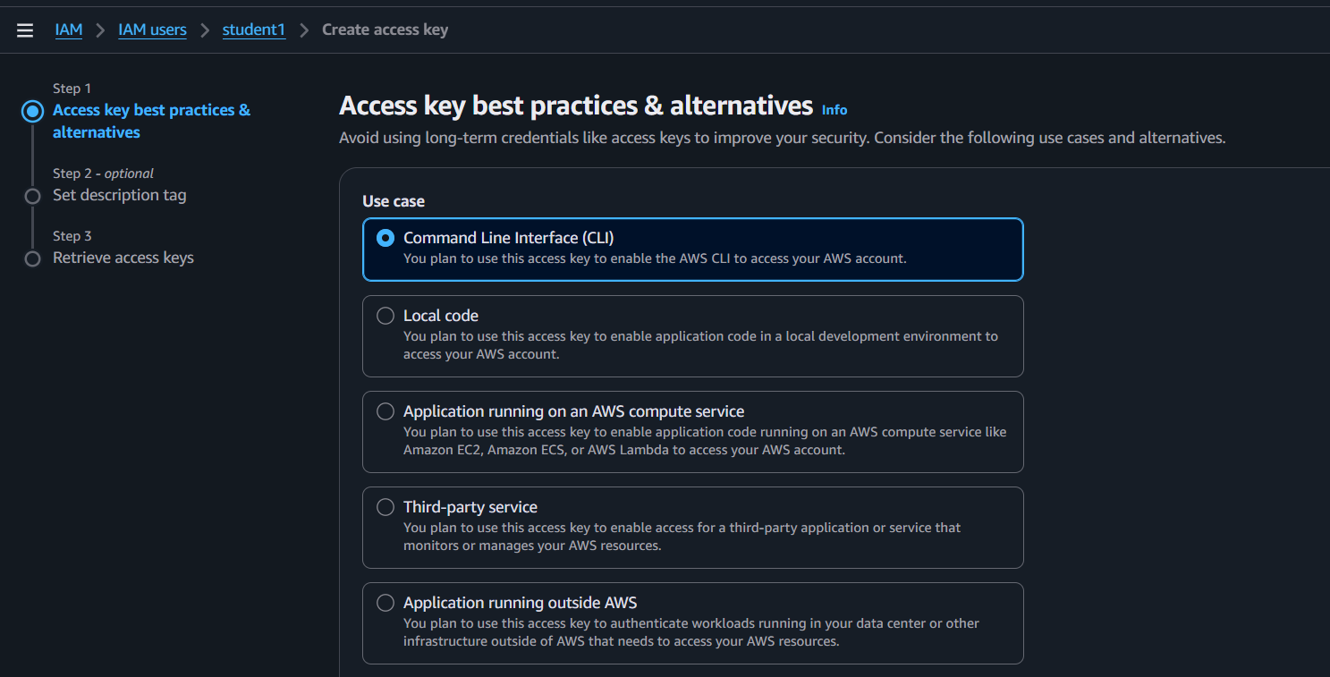
Figure: Step 2
Step 3 – Choose Command Line Interface (CLI) and continue.

Step 4 – Enter an optional description and create the access key.
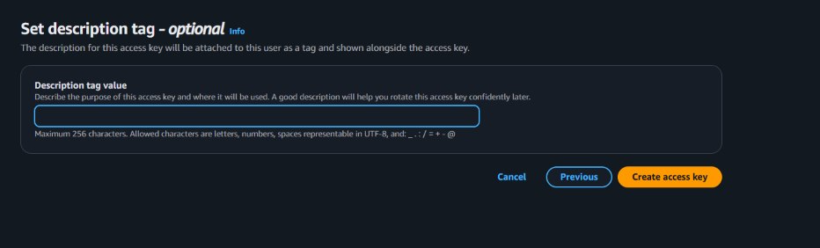

Step 5 – Download the CSV file containing the Access Key ID and Secret Access Key.
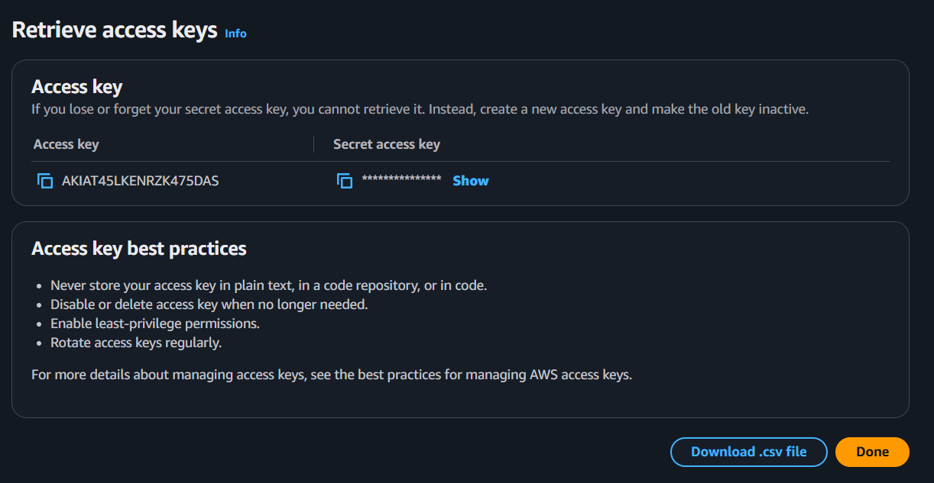

Step 6 – Check that the credentials file is downloaded. Keep it private.
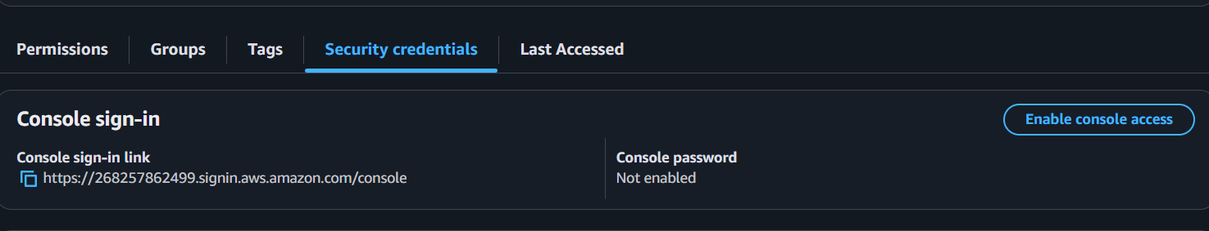

Part C: Configure AWS Free Tier Usage Alerts
Step 1 – Search for Billing and Cost Management and open it.
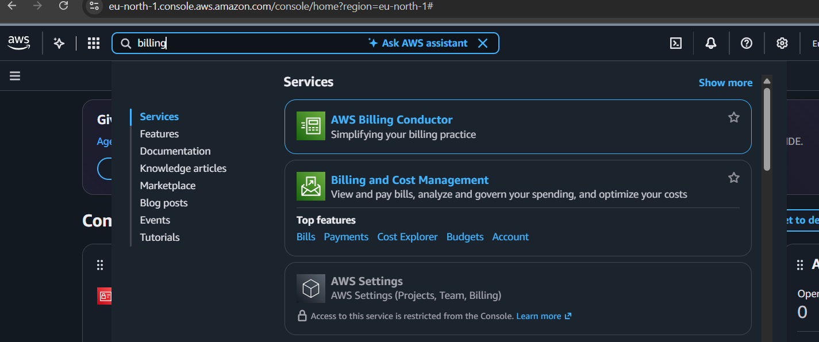
Step 2 – Open Billing preferences from the Preferences menu.
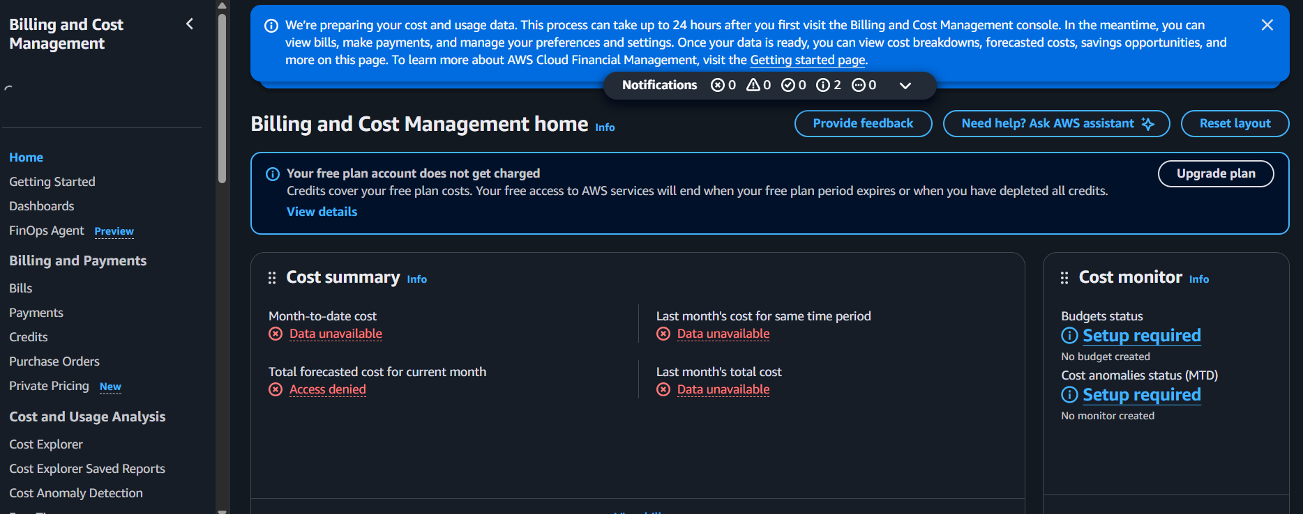

Step 3 – Enable Receive AWS Free Tier usage alerts.

Step 4 – Enter an email address if required, then click Update.
Figure: Step 4
Step 5 – Check that the Free Tier alert option is enabled.

Part D: Configure AWS Billing Alerts Using a Budget
Step 1 – Open Budgets under Budgets and Planning.
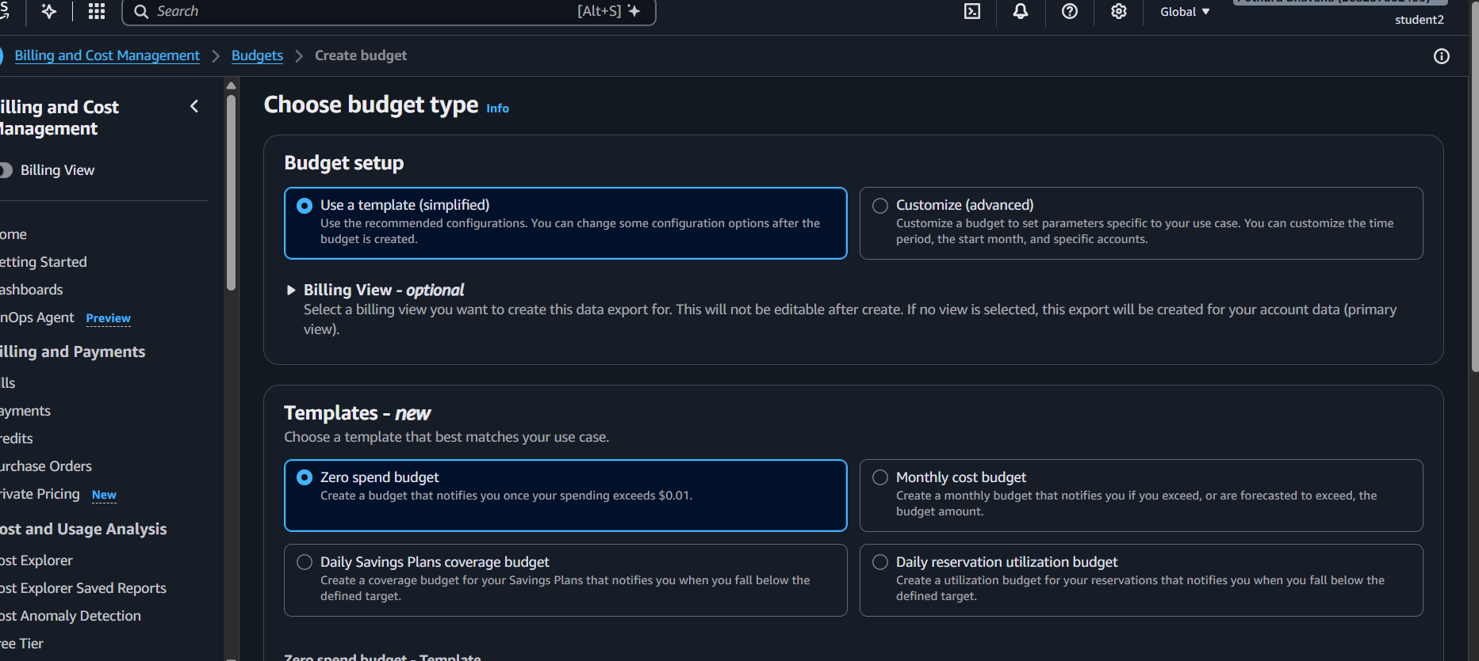

Step 2 – Click Create budget and select a budget setup.

Step 3 – Choose Zero spend budget or select Customize (advanced).

Step 4 – For a custom budget, select Cost budget and enter the budget details.
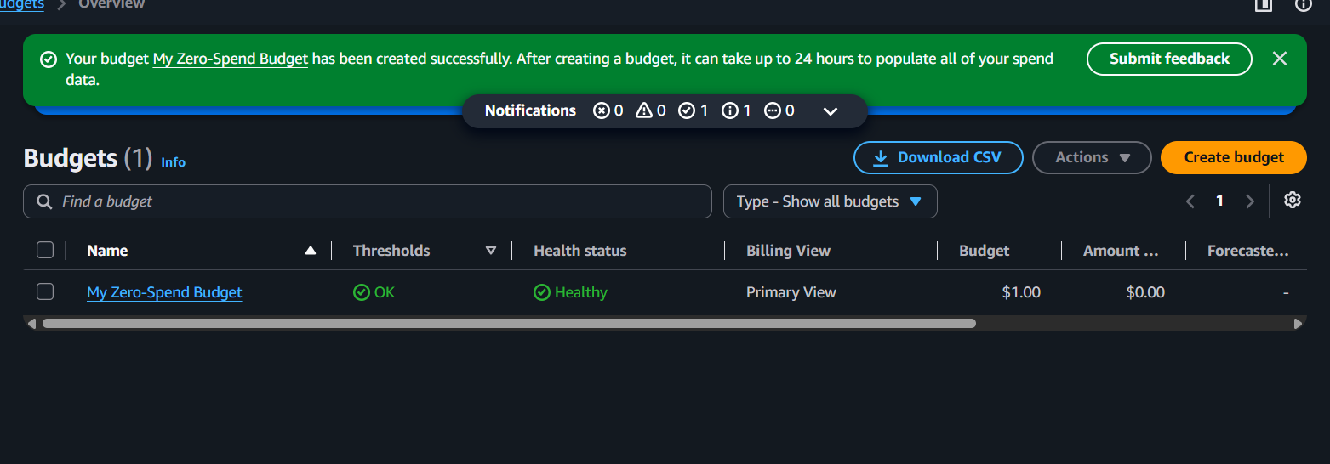

Step 5 – Set the alert threshold and enter your email address.
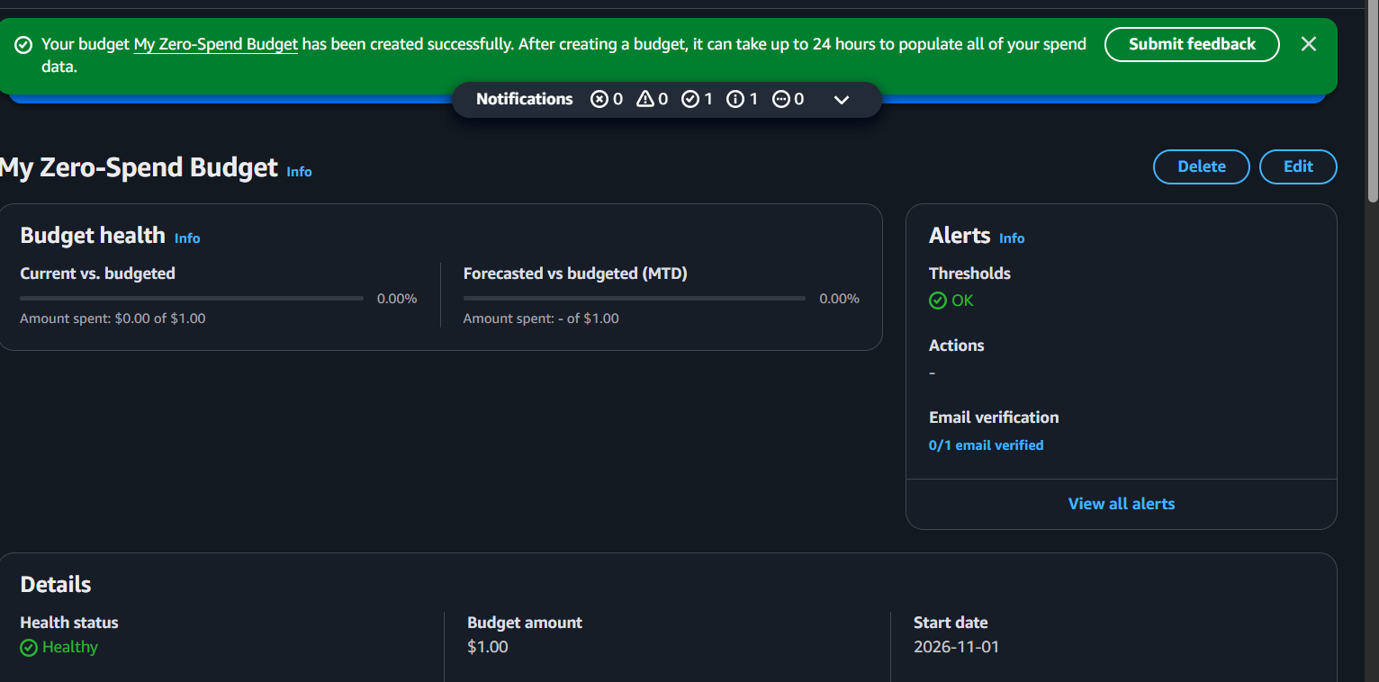

Step 6 – Review the budget details and click Create budget.

Step 7 – Check the Budgets dashboard to confirm that the budget is created.

Step 8 – Check your email for budget notifications when the alert condition is reached.
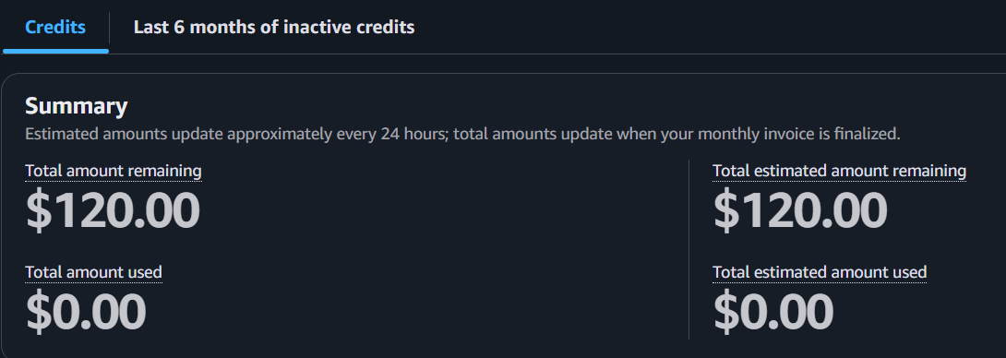

Result
An IAM user was created, access keys were generated and downloaded, and AWS Free Tier and billing budget alerts were configured.

